Chapter 14
Capital Structure in a Perfect Market
14-1. Consider a project with free cash flows in one year of $130,000 or $180,000, with each outcome being equally likely. The initial investment required for the project is $100,000, and the project’s cost of capital is 20%. The risk-free interest rate is 10%.
a. What is the NPV of this project?
b. Suppose that to raise the funds for the initial investment, the project is sold to investors as an all-equity firm. The equity holders will receive the cash flows of the project in one year. How much money can be raised in this way—that is, what is the initial market value of the unlevered equity?
c. Suppose the initial $100,000 is instead raised by borrowing at the risk-free interest rate. What are the cash flows of the levered equity, and what is its initial value according to MM?
a. 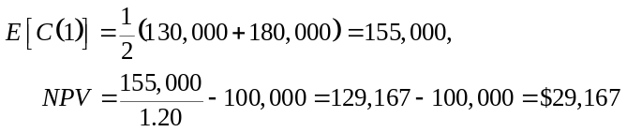
b. 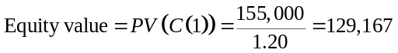
c. Debt payments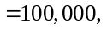 equity receives 20,000 or 70,000.
Initial value, by MM, is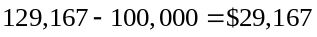.
14-2. You are an entrepreneur starting a biotechnology firm. If your research is successful, the technology can be sold for $30 million. If your research is unsuccessful, it will be worth nothing. To fund your research, you need to raise $2 million. Investors are willing to provide you with $2 million in initial capital in exchange for 50% of the unlevered equity in the firm.
a. What is the total market value of the firm without leverage?
b. Suppose you borrow $1 million. According to MM, what fraction of the firm’s equity will you need to sell to raise the additional $1 million you need?
c. What is the value of your share of the firm’s equity in cases (a) and (b)?
a. Total value of equity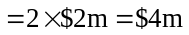
b. MM says total value of firm is still $4 million. $1 million of debt implies total value of equity is $3 million. Therefore, 33% of equity must be sold to raise $1 million.
c. In (a), 50% × $4m = $2m. In (b), 2/3 × $3m = $2m. Thus, in a perfect market the choice of capital structure does not affect the value to the entrepreneur.
14-3. Acort Industries owns assets that will have an 80% probability of having a market value of $50 million in one year. There is a 20% chance that the assets will be worth only $20 million. The current risk-free rate is 5%, and Acort’s assets have a cost of capital of 10%.
a. If Acort is unlevered, what is the current market value of its equity?
b. Suppose instead that Acort has debt with a face value of $20 million due in one year. According to MM, what is the value of Acort’s equity in this case?
c. What is the expected return of Acort’s equity without leverage? What is the expected return of Acort’s equity with leverage?
d. What is the lowest possible realized return of Acort’s equity with and without leverage?
a. E[Value in one year]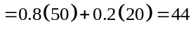.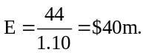
b. D =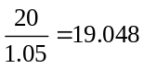. Therefore,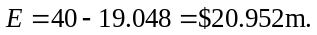
c. Without leverage, r =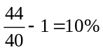, with leverage, r =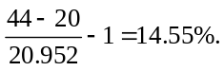
d. Without leverage, r =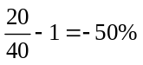, with leverage, r =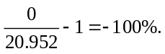
14-4. Wolfrum Technology (WT) has no debt. Its assets will be worth $450 million in one year if the economy is strong, but only $200 million in one year if the economy is weak. Both events are equally likely. The market value today of its assets is $250 million.
a. What is the expected return of WT stock without leverage?
b. Suppose the risk-free interest rate is 5%. If WT borrows $100 million today at this rate and uses the proceeds to pay an immediate cash dividend, what will be the market value of its equity just after the dividend is paid, according to MM?
c. What is the expected return of WT stock after the dividend is paid in part (b)?
a. (0.5 × 450 + 0.5 × 200)/250 = 1.30 => 30%
b. E + D = 250, D = 100 => E = 150
c. (0.5 × (450 – 105) + 0.5 × (200 – 105))/150 = 1.4667 => 46.67%

14-5. Suppose there are no taxes. Firm ABC has no debt, and firm XYZ has debt of $5000 on which it pays interest of 10% each year. Both companies have identical projects that generate free cash flows of $800 or $1000 each year. After paying any interest on debt, both companies use all remaining free cash flows to pay dividends each year.
a. Fill in the table below showing the payments debt and equity holders of each firm will receive given each of the two possible levels of free cash flows.
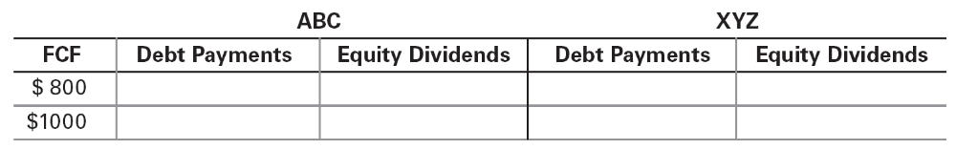
b. Suppose you hold 10% of the equity of ABC. What is another portfolio you could hold that would provide the same cash flows?
c. Suppose you hold 10% of the equity of XYZ. If you can borrow at 10%, what is an alternative strategy that would provide the same cash flows?
a.
 | ABC |  | XYZ
FCF | Debt Payments | Equity Dividends | Debt Payments | Equity Dividends
$800 | 0 | 800 | 500 | 300
$1,000 | 0 | 1000 | 500 | 500
b. Unlevered Equity = Debt + Levered Equity. Buy 10% of XYZ debt and 10% of XYZ Equity, get 50 + (30, 50) = (80,100)
c. Levered Equity = Unlevered Equity + Borrowing. Borrow $500, buy 10% of ABC, receive (80,100) – 50 = (30, 50)
14-6. Suppose Alpha Industries and Omega Technology have identical assets that generate identical cash flows. Alpha Industries is an all-equity firm, with 10 million shares outstanding that trade for a price of $22 per share. Omega Technology has 20 million shares outstanding as well as debt of $60 million.
a. According to MM Proposition I, what is the stock price for Omega Technology?
b. Suppose Omega Technology stock currently trades for $11 per share. What arbitrage opportunity is available? What assumptions are necessary to exploit this opportunity?
a. V(Alpha) = 1022 = 220m = V(Omega) = D + E ⇒ E = 220 – 60 = 160m ⇒ p = $8 per share.
b. Omega is overpriced. Sell 20 Omega, buy 10 Alpha, and borrow 60. Initial = 220 – 220 + 60 = 60. Assumes we can trade shares at current prices and that we can borrow at the same terms as Omega (or own Omega debt and can sell at same price).
14-7. Cisoft is a highly profitable technology firm that currently has $5 billion in cash. The firm has decided to use this cash to repurchase shares from investors, and it has already announced these plans to investors. Currently, Cisoft is an all-equity firm with 5 billion shares outstanding. These shares currently trade for $12 per share. Cisoft has issued no other securities except for stock options given to its employees. The current market value of these options is $8 billion.
a. What is the market value of Cisoft’s non-cash assets?
b. With perfect capital markets, what is the market value of Cisoft’s equity after the share repurchase? What is the value per share?
a. Assets = cash + non-cash, Liabilities = equity + options, Non-cash assets = equity + options – cash = 12 × 5 + 8 – 5 = 63 billion.
b. Equity = 60 – 5 =55. Repurchase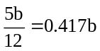shares ⇒ 4.583 b shares remain.
Per share value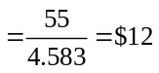.
14-8. Schwartz Industry is an industrial company with 100 million shares outstanding and a market capitalization (equity value) of $4 billion. It has $2 billion of debt outstanding. Management have decided to delever the firm by issuing new equity to repay all outstanding debt.
a. How many new shares must the firm issue?
b. Suppose you are a shareholder holding 100 shares, and you disagree with this decision. Assuming a perfect capital market, describe what you can do to undo the effect of this decision.
a. Share price = 4b/100m = $40, Issue 2b/40 = 50 million shares
b. You can undo the effect of the decision by borrowing to buy additional shares, in the same proportion as the firm’s actions, thus relevering your own portfolio. In this case you should buy 50 new shares and borrow $2000.
14-9. Zetatron is an all-equity firm with 100 million shares outstanding, which are currently trading for $7.50 per share. A month ago, Zetatron announced it will change its capital structure by borrowing $100 million in short-term debt, borrowing $100 million in long-term debt, and issuing $100 million of preferred stock. The $300 million raised by these issues, plus another $50 million in cash that Zetatron already has, will be used to repurchase existing shares of stock. The transaction is scheduled to occur today. Assume perfect capital markets.
a. What is the market value balance sheet for Zetatron
i. Before this transaction?
ii. After the new securities are issued but before the share repurchase?
iii. After the share repurchase?
b. At the conclusion of this transaction, how many shares outstanding will Zetatron have, and what will the value of those shares be?
a. i. 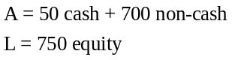
ii.
iii.
b. Repurchase 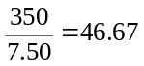shares ⇒ 53.33 remain. Value is 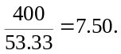
14-10. Explain what is wrong with the following argument: “If a firm issues debt that is risk free, because there is no possibility of default, the risk of the firm’s equity does not change. Therefore, risk-free debt allows the firm to get the benefit of a low cost of capital of debt without raising its cost of capital of equity.”
Any leverage raises the equity cost of capital. In fact, risk-free leverage raises it the most (because it does not share any of the risk).
14-11. Consider the entrepreneur described in Section 14.1 (and referenced in Tables 14.1–14.3). Suppose she funds the project by borrowing $750 rather than $500.
a. According to MM Proposition I, what is the value of the equity? What are its cash flows if the economy is strong? What are its cash flows if the economy is weak?
b. What is the return of the equity in each case? What is its expected return?
c. What is the risk premium of equity in each case? What is the sensitivity of the levered equity return to systematic risk? How does its sensitivity compare to that of unlevered equity? How does its risk premium compare to that of unlevered equity?
d. What is the debt-equity ratio of the firm in this case?
e. What is the firm’s WACC in this case?
a. E = 1000 – 750 = 250. CF = (1400,900) – 500 (1.05) = (612.5,112.5)
b. R_{e} = (145%, – 55%), E[Re] = 45%, Risk premium = 45% – 5% = 40%
c. Return sensitivity = 145% – (–55%) = 200%. This sensitivity is 4x the sensitivity of unlevered equity (50%). Its risk premium is also 4× that of unlevered equity (40% vs. 10%).
d. 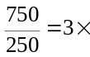
e. 25%(45%) + 75%(5%) = 15%
14-12. Hardmon Enterprises is currently an all-equity firm with an expected return of 12%. It is considering a leveraged recapitalization in which it would borrow and repurchase existing shares.
a. Suppose Hardmon borrows to the point that its debt-equity ratio is 0.50. With this amount of debt, the debt cost of capital is 6%. What will the expected return of equity be after this transaction?
b. Suppose instead Hardmon borrows to the point that its debt-equity ratio is 1.50. With this amount of debt, Hardmon’s debt will be much riskier. As a result, the debt cost of capital will be 8%. What will the expected return of equity be in this case?
c. A senior manager argues that it is in the best interest of the shareholders to choose the capital structure that leads to the highest expected return for the stock. How would you respond to this argument?
a. r_{e} = r_{u} + d/e(r_{u} – r_{d}) = 12% + 0.50(12% – 6%) = 15%
b. r_{e} = 12% + 1.50(12% – 8%) = 18%
c. Returns are higher because risk is higher—the return fairly compensates for the risk. There is no free lunch.
14-13. Suppose The Washington Post Company (WPO) has no debt and an equity cost of capital of 9.2%. The average debt-to-value ratio for the publishing industry is 13%. What would its cost of equity be if it took on the average amount of debt for its industry at a cost of debt of 6%?
At a cost of debt of 6%:
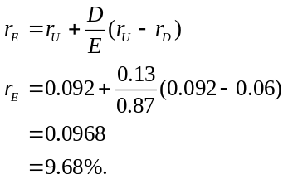
14-14. Global Pistons (GP) has common stock with a market value of $200 million and debt with a value of $100 million. Investors expect a 15% return on the stock and a 6% return on the debt. Assume perfect capital markets.
a. Suppose GP issues $100 million of new stock to buy back the debt. What is the expected return of the stock after this transaction?
b. Suppose instead GP issues $50 million of new debt to repurchase stock.
i. If the risk of the debt does not change, what is the expected return of the stock after this transaction?
ii. If the risk of the debt increases, would the expected return of the stock be higher or lower than in part (i)?
a. 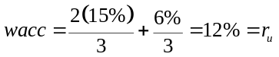.
b. i. 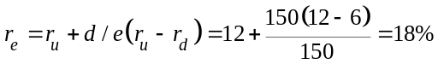
ii. if r_{d} is higher, r_{e} is lower. The debt will share some of the risk.
14-15. Hubbard Industries is an all-equity firm whose shares have an expected return of 10%. Hubbard does a leveraged recapitalization, issuing debt and repurchasing stock, until its debt-equity ratio is 0.60. Due to the increased risk, shareholders now expect a return of 13%. Assuming there are no taxes and Hubbard’s debt is risk free, what is the interest rate on the debt?
14-16. Hartford Mining has 50 million shares that are currently trading for $4 per share and $200 million worth of debt. The debt is risk free and has an interest rate of 5%, and the expected return of Hartford stock is 11%. Suppose a mining strike causes the price of Hartford stock to fall 25% to $3 per share. The value of the risk-free debt is unchanged. Assuming there are no taxes and the risk (unlevered beta) of Hartford’s assets is unchanged, what happens to Hartford’s equity cost of capital?
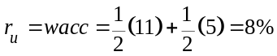. 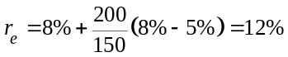
14-17. Mercer Corp. is an all-equity firm with 10 million shares outstanding and $100 million worth of debt outstanding. Its current share price is $75. Mercer’s equity cost of capital is 8.5%. Mercer has just announced that it will issue $350 million worth of debt. It will use the proceeds from this debt to pay off its existing debt, and use the remaining $250 million to pay an immediate dividend. Assume perfect capital markets.
a. Estimate Mercer’s share price just after the recapitalization is announced, but before the transaction occurs.
b. Estimate Mercer’s share price at the conclusion of the transaction. (Hint: use the market value balance sheet.)
c. Suppose Mercer’s existing debt was risk-free with a 4.25% expected return, and its new debt is risky with a 5% expected return. Estimate Mercer’s equity cost of capital after the transaction.
a. MM => no change, $75
b. Initial enterprise value = 75 × 10 + 100 = 850 million
New debt = 350 million
E = 850 – 350 = 500
Share price = 500/10 = $50
c. Ru = (750/850) × 8.5% + (100/850) × 4.25% = 8%
Re = 8% + 350/500(8% – 5%) = 10.1%
14-18. In mid-2012, AOL Inc. had $100 million in debt, total equity capitalization of $3.1 billion, and an equity beta of 0.90 (as reported on Yahoo! Finance). Included in AOL’s assets was $1.5 billion in cash and risk-free securities. Assume that the risk-free rate of interest is 3% and the market risk premium is 4%.
a. What is AOL’s enterprise value?
b. What is the beta of AOL’s business assets?
c. What is AOL’s WACC?
a. 3.1 + 0.1 – 1.5 = 1.7 billion
b. Because the debt is risk free, 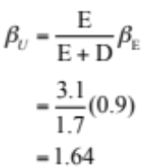
c. 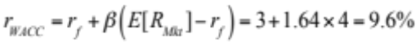
alternatively
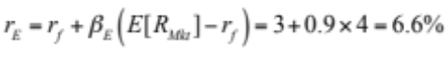
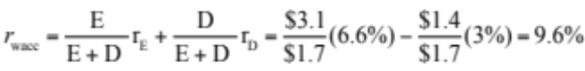
14-19. Indell stock has a current market value of $120 million and a beta of 1.50. Indell currently has risk-free debt as well. The firm decides to change its capital structure by issuing $30 million in additional risk-free debt, and then using this $30 million plus another $10 million in cash to repurchase stock. With perfect capital markets, what will be the beta of Indell stock after this transaction?
Indell increases its net debt by $40 million ($30 million in new debt + $10 million in cash paid out). Therefore, the value of its equity decreases to 120 – 40 = $80 million.
If the debt is risk-free:
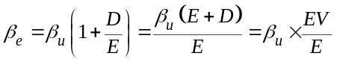,
where D is net debt, and EV is enterprise value . The only change in the equation is the value of equity. Therefore
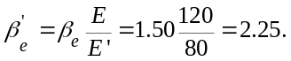
14-20. Yerba Industries is an all-equity firm whose stock has a beta of 1.2 and an expected return of 12.5%. Suppose it issues new risk-free debt with a 5% yield and repurchases 40% of its stock. Assume perfect capital markets.
a. What is the beta of Yerba stock after this transaction?
b. What is the expected return of Yerba stock after this transaction?
Suppose that prior to this transaction, Yerba expected earnings per share this coming year of $1.50, with a forward P/E ratio (that is, the share price divided by the expected earnings for the coming year) of 14.
c. What is Yerba’s expected earnings per share after this transaction? Does this change benefit shareholders? Explain.
d. What is Yerba’s forward P/E ratio after this transaction? Is this change in the P/E ratio reasonable? Explain.
a. 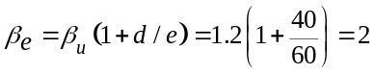
b. from the CAPM, or
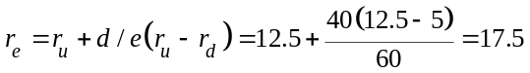
c. 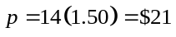. Borrow 40%(21) = 8.4, interest = 5%(8.4) = 0.42. Earnings = 1.50 – 0.42 = 1.08, per share 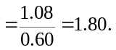
No benefit; risk is higher. The stock price does not change.
d. 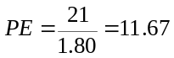. It falls due to higher risk.
14-21. You are CEO of a high-growth technology firm. You plan to raise $180 million to fund an expansion by issuing either new shares or new debt. With the expansion, you expect earnings next year of $24 million. The firm currently has 10 million shares outstanding, with a price of $90 per share. Assume perfect capital markets.
a. If you raise the $180 million by selling new shares, what will the forecast for next year’s earnings per share be?
b. If you raise the $180 million by issuing new debt with an interest rate of 5%, what will the forecast for next year’s earnings per share be?
c. What is the firm’s forward P/E ratio (that is, the share price divided by the expected earnings for the coming year) if it issues equity? What is the firm’s forward P/E ratio if it issues debt? How can you explain the difference?
a. Issue 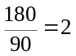 million new shares ⇒ 12 million shares outstanding.
New EPS 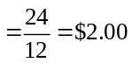 per share.
b. Interest on new debt 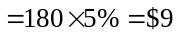 million. The interest expense will reduce earnings to 24 – 9 = $15 million. With 10 million shares outstanding, 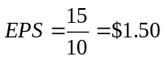per share.
c. By MM, share price is $90 in either case. PE ratio with equity issue is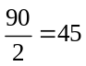.
PE ratio with debt is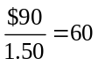.
The higher PE ratio is justified because with leverage, EPS will grow at a faster rate.
14-22. Zelnor, Inc., is an all-equity firm with 100 million shares outstanding currently trading for $8.50 per share. Suppose Zelnor decides to grant a total of 10 million new shares to employees as part of a new compensation plan. The firm argues that this new compensation plan will motivate employees and is a better strategy than giving salary bonuses because it will not cost the firm anything.
a. If the new compensation plan has no effect on the value of Zelnor’s assets, what will be the share price of the stock once this plan is implemented?
b. What is the cost of this plan for Zelnor’s investors? Why is issuing equity costly in this case?
a. Assets = 850m. New shares = 110. 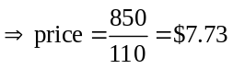
b. Cost = 100(8.50 – 7.73) = 77 m = 10(7.73). Issuing equity at below market price is costly.

14-23. Suppose Levered Bank is funded with 2% equity and 98% debt. Its current market capitalization is $10 billion, and its market to book ratio is 1. Levered Bank earns a 4.22% expected return on its assets (the loans it makes), and pays 4% on its debt.
New capital requirements will necessitate that Levered Bank increase its equity to 4% of its capital structure. It will issue new equity and use the funds to retire existing debt. The interest rate on its debt is expected to remain at 4%.
a. What is Levered Bank’s expected ROE with 2% equity?
b. Assuming perfect capital markets, what will Levered Bank’s expected ROE be after it increases its equity to 4%?
c. Consider the difference between Levered Bank’s ROE and its cost of debt. How does this “premium” compare before and after the Bank’s increase in leverage?
d. Suppose the return on Levered Bank’s assets has a volatility of 0.25%. What is the volatility of Levered Bank’s ROE before and after the increase in equity?
e. Does the reduction in Levered Bank’s ROE after the increase in equity reduce its attractiveness to shareholders? Explain.
a. Assets = 10/.02 = 500
500 × 4.22% – 490 × 4% = 1.5
1.5/10 = 15% ROE
b. Equity → $20 billion
Earnings = 15% × 10 + 4% × 10 = 19% × 10
ROE = 19% × 10 / 20 = 9.5%
c. 11% vs 5.5%—premium drops in half
d. Vol = 500 × 0.25%/10 = 12.5% before, vs 500 × 0.25%/20 = 6.25% after.
e. No, premium and risk both fall by half.

